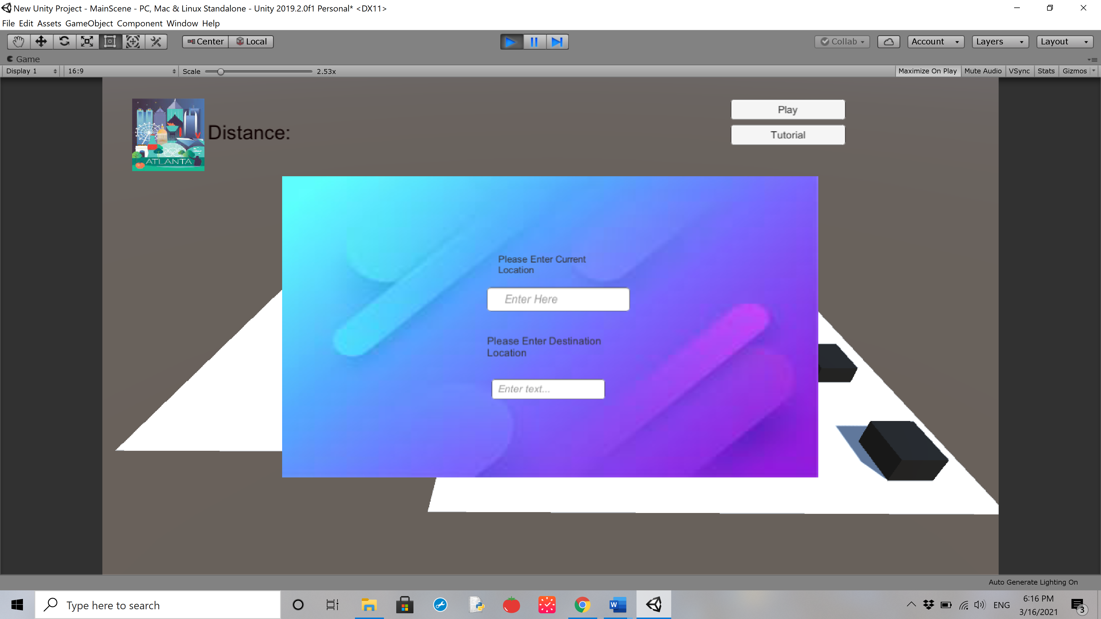

Buttons

Text

Image

Input Field